Springwell Primary School
Science Focus: Living things and their habitats |  | Year 2 Spring Term
What should I already know? |  | What will I know by the end of the unit?
- Names of different mini-beasts and where to find them.  - How to classify them.  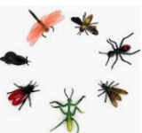  - That animals can be carnivores, omnivores and herbivores. |  | - The difference between things that are living, dead and things that have never been alive.  - That most living things live in habitats to which they are suited.  - An understanding of how different habitats provide for basic needs for different kinds of animals and plants, and how they depend on each other.  - A variety of plants and animals in their habitats, including micro-habitats.  - How animals obtain their food from plants and other animals.  - How a simple food chain works.  - Different sources of food.
Vocabulary
Vocabulary | Definition
Depend | Many living things in a habitat depend on each other. This means they need each other for different things. |  | 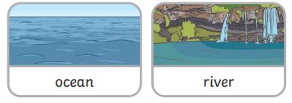  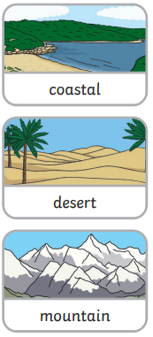  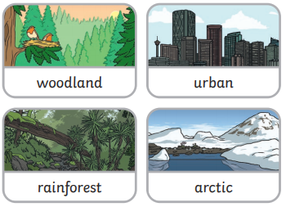
Microhabitat | A microhabitat is a very small habitat found in places like under a rock, under leavers or on a branch. Mini-beasts live in microhabitats. The microhabitats have everything they need to survive.
Survive | This means to stay alive.
Habitat | A habitat is the natural place something lives.  A habitat provides living things with everything they need to survive such as food, shelter and water.
Examples of micro habitats
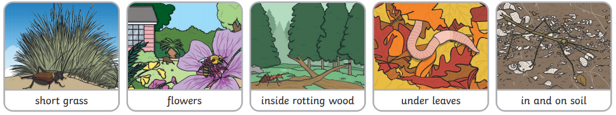

Possible experiences
- Visiting different microhabitats around school
- Ant farm observations

