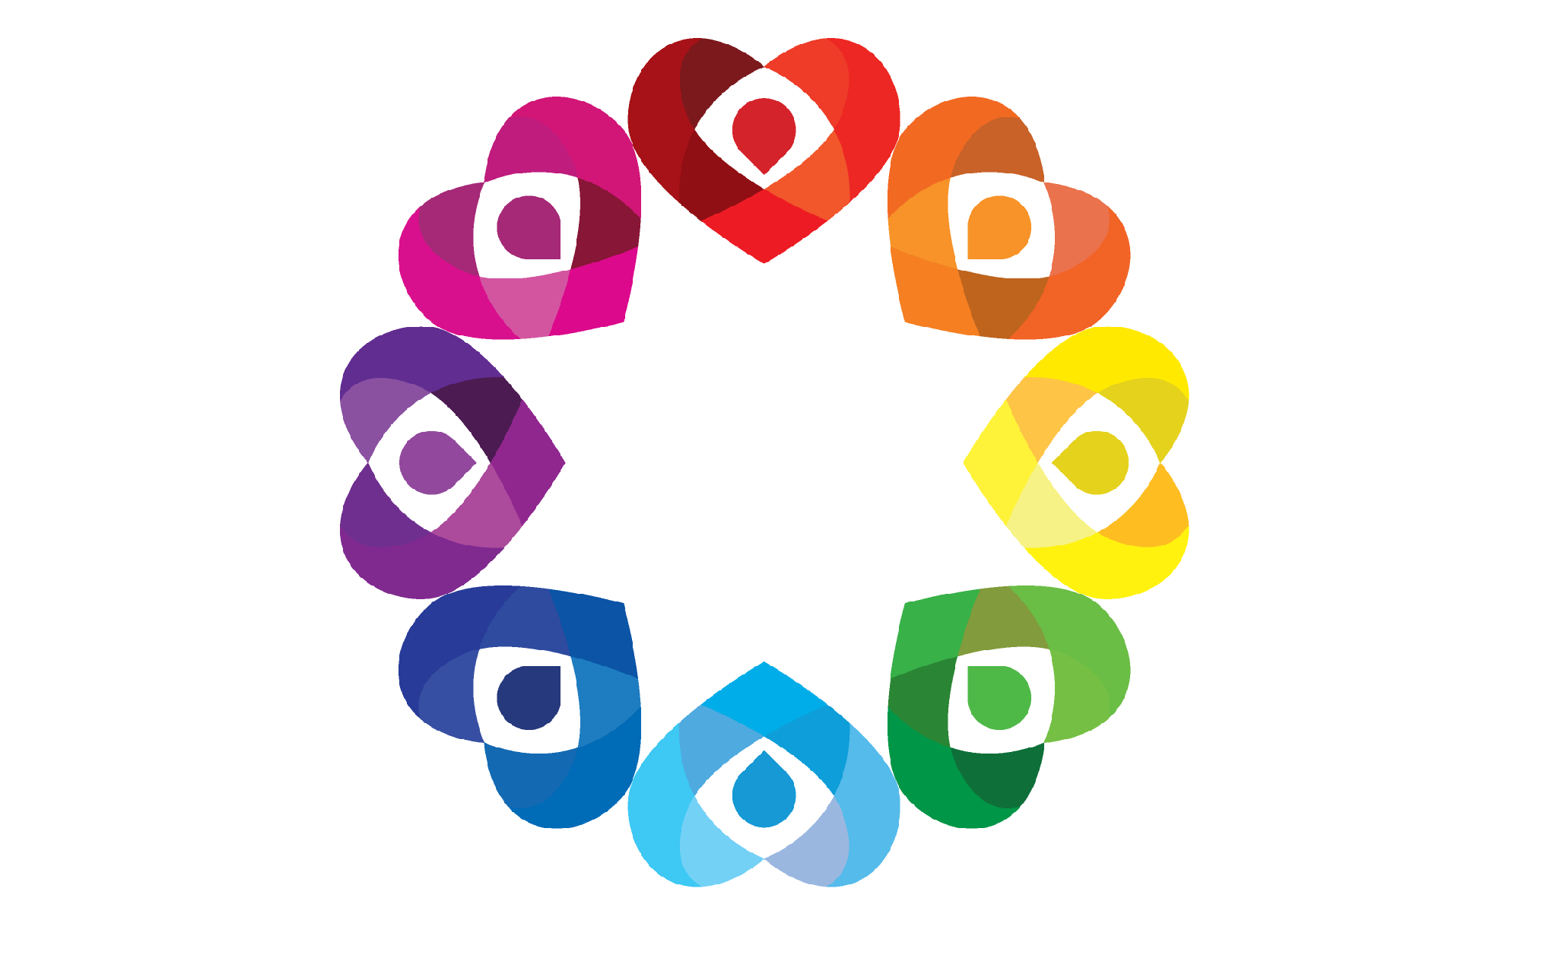

Anti – Bullying
Policy

September 2026

Our mission is to provide a happy nurturing environment which develops the necessary life skills
for all our children to enjoy learning irrespective of race, colour, creed or impairment.

Introduction

We believe that it is every child’s right to be safe and to feel safe. We take bullying very seriously.

Everyone at Springwell Park School has the right to feel welcome, secure and happy. Only if this is the case will all members of the school community be able to achieve to their maximum potential. Bullying of any sort prevents this being able to happen and prevents equality of opportunity. It is everyone’s responsibility to prevent this happening and this policy contains guidelines to support this ethos.
Where bullying exists, the victims must feel confident to activate the anti-bullying systems within the school to end the bullying. It is our aim to challenge attitudes about bullying behaviour, increase understanding for bullied pupils and help build an anti-bullying ethos in the school.

This document outlines how we make this possible at Springwell Park.

(The terms “bully” or “perpetrator” and “victim” is used in this policy but it is not good practice to label children in this way and language to describe the behaviours should be used rather than language defining them as a person)

What is bullying?

Bullying is deliberately hurtful behaviour that is repeated over a period of time, making it difficult for the person concerned to defend themselves. This can take the form of name-calling, violence, threatened violence, isolation, ridicule or indirect action such as spreading unpleasant stories about someone. This behaviour also relates to threatening or unpleasant emails or texts and the use of social networking sites to threaten or intimidate. For the purpose of this policy, “bullying” is defined as persistent behaviour by an individual or group with the intention of verbally, physically, or emotionally harming another person or group. Bullying is generally characterised by:

- Repetition: Incidents are not one-offs; they are frequent and happen over an extended period of time.
- Intent: The perpetrator means to cause verbal, physical or emotional harm; it is not accidental.
- Targeting: Bullying is generally targeted at a specific individual or group.

The school works hard to ensure that all pupils know the difference between bullying and simply “falling out”.

Vulnerable pupils are more likely to be the targets of bullying due to the attitudes and behaviours some young people have towards those who are different from themselves. Vulnerable pupils may include, but are not limited to:

Pupils who are adopted.

Pupils suffering from a health problem.

Pupils with caring responsibilities.

Pupils from socioeconomically disadvantaged backgrounds.

Pupils with certain characteristics are also more likely to be targets of bullying, including, but not limited to:

Pupils who are LGBTQ+, or perceived to be LGBTQ+.

Black, Asian and minority ethnic (BAME) pupils.

Pupils with SEND.
.

See appendix 1 for a full list of examples

All bullying is aggression, although not all aggression is bullying.

What types of bullying are there?

- Emotional (being unfriendly, excluding, tormenting, threatening behaviour)
- Verbal (name calling, sarcasm, spreading rumours, teasing)
- Physical (pushing, kicking, hitting, punching or any use of violence)
- Racist (racial taunts, graffiti, gestures)
- Sexual (unwanted physical contact, sexually abusive comments)
- Homophobic (because of, or focusing on the issue of sexuality)
- Cyber (all areas of internet, email and internet chatroom misuse)
- Mobile threats by text messaging and calls.

What are the signs and symptoms of bullying?

A person may indicate by signs or behaviours that they are being bullied. Warning signs of bullying could include:
- Frightened of walking to or from school or changes route
- Doesn’t want to go to school
- Pretends to be ill when it’s time for school
- Loses interest in school work
- Has injuries that are unexplained
- Changes their usual routine
- Becomes withdrawn, anxious or lacking in confidence
- Becomes aggressive, abusive, disruptive or unreasonable
- Threatens or attempts suicide / self – harm (advice should be sought from GP straight away)
- Threatens or attempts to run away
- Cries themselves to sleep at night or has nightmares
- Asks for money or starts stealing money
- Changes in eating habits
- Comes home having ‘lost’ possessions
- Is frightened to say what is wrong
- Afraid to use the internet or mobile phone
- Nervous or jumpy when a cyber message is received
- Gives improbable excuses for their behaviour.

What causes Bullying?

People bully for different reasons. The reasons could be:

- To feel powerful
- Jealousy
- To feel good about themselves
- To be in control
- Because they want something (attention, possession or friends)
- To look good in front of other people
- To feel popular
- Because of peer pressure
- For fun
- Because they are being bullied themselves

How can we prevent Bullying?

At Springwell Park we foster a clear understanding that bullying, in any form, is not acceptable. As part of our strategy for promoting positive behaviour we look at attitudes, skills and activities which will prevent bullying. As a whole school we will:

- Ensure that all pupils are familiar with our code of conduct which is displayed in every classroom and around school.
- Use the curriculum whenever possible to reinforce the ethos of the school and help pupils to develop strategies to combat bullying-type behaviour
- Implement a planned teaching and learning programme to develop understandings and skills to support positive relationships and to engage with a supportive network. This programme will take the form of whole school focus weeks.
- Raise awareness through our Anti-bullying week in which we will address the following types of bullying – race, religion, disability, gender, homophobic and cyber. This programme also addresses the use of inappropriate use of language.
- Promote our Springwell Values as a consistent approach.
- Develop an effective anti-bullying policy and practice which is communicated to all shareholders
- Give regular praise of positive and supportive behaviour by all staff
- Model good practice showing respect, empathy and genuineness
- Provide ease of access to the school pastoral system and external confidential services
- Provide staff training related to both awareness, teaching and learning and response to incidents
- Regularly monitor areas such as playground and travel to school
- Conduct termly interviews with pupils regarding behaviour and bullying
- Keep records of any reported incidents on CPOMs.

What if there are bullying incidents?
At Springwell Park we will be vigilant for signs of bullying and always take reports of incidents seriously.

- If a person becomes aware of a bullying incident, it should be reported. A record will be kept of incidents on CPOMS. Any young person who is suffering should be supported and the incident should be investigated. All proven incidences of bullying should be reported to the Headteacher or Assistant Headteachers.
- A pastoral action plan will be completed for the perpetrator to address this behaviour and for the victim to offer support.
- Where appropriate Learning Mentors deliver focused PSHE sessions to classes or small groups to promote and support collaborative support from peers.

See School Councils note for children about what to do if being bullied – Appendix 2

Strategies For Dealing With Bullying

The following is a list of actions available to staff depending on the perceived seriousness of the situation. The emphasis is always on a caring, listening approach as bullies are often victims too – that is why they bully.
If bullying is suspected the following strategies may be used:

- Talk to the suspected victim, and any witnesses.
- Inform a senior member of staff and log the concern on CPOMS.
- Identify the alleged bully and talk about what has happened, to discover why they became involved. Make it clear that bullying is not tolerated at Springwell Park.
- Investigate further and monitor the situation to try and find a pattern in the behaviour.
- If the bully owns up then appropriate sanctions will be put into place.
- Restorative sessions are offered (led by the Pastoral Team) involving children and parents.
- Bully Buster intervention for perpetrator and victim delivering 1:1, group or class support.
- Incidents of all bullying are recorded as such on the School CPOMS system (including Racist and Homophobic language). All actions to be logged here also.
- A pastoral support action plan will be drawn up for both the victim and perpetrator. This will be reviewed regularly.
- A risk assessment will be put in place for the perpetrator if necessary.
- Keep the parents informed at regular intervals.

Our response will always consist of:
- Valuing the self- esteem of all involved
- Safeguarding the health and well-being of all pupils
- Involving children in the decision- making processes
- Intervention work with the perpetrator.
- Sanctions appropriate to age of child and nature of incident
- A no blame approach (Mains and Robinson), which seeks to get all parties to understand and explain how, each other feel or similarly a restorative practice approach.
- Support from the police if necessary

An incident may throw –up a number of issues, which require the involvement of the school’s Designated Safeguarding Lead. They will be kept informed.

Child-on-child abuse

Springwell Park has a zero-tolerance approach to all forms of child-on-child abuse, including sexual harassment and sexual violence.
To prevent child-on-child abuse and address the wider societal factors that can influence behaviour, the school will educate pupils about abuse, its forms, and the importance of discussing any concerns and respecting others through the curriculum, assemblies and PSHE lessons.

All staff will:
- Be aware that pupils of any age and gender are capable of abusing their peers.
- Be aware that abuse can occur inside and outside of school settings.
- Be aware of the scale of harassment or abuse, and that just because it is not being reported does not mean it is not happening.
- Take all instances of child-on-child abuse equally seriously regardless of the characteristics of the perpetrators or victims.
- Never tolerate abuse as “banter” or “part of growing up”, and will never justify sexual harassment, e.g. as “boys being boys”, as this can foster a culture of unacceptable behaviours and one that risks normalising abuse.
- Always challenge any harmful physical behaviour that is sexual in nature, such inappropriate touching. Dismissing or tolerating such behaviours risks normalising them.

Pupils will be made aware of how to raise concerns or make a report and how any reports will be handled – this includes the process for reporting concerns about friends or peers. If a pupil has been harmed, is in immediate danger or is at risk of harm, a referral may be made to children’s social care services (CSCS) and potentially the police, where the DSL deems this appropriate in the circumstances.
All staff will be aware and sensitive towards the fact that pupils may not be ready or know how to tell someone that they are being abused. Pupils being abused may feel embarrassed, humiliated, scared, or threatened.

External support / agencies
We will use as appropriate external support services such as Educational Welfare Service, school nurses and Bully Busters.

- Mental Health Support Team
- Education Welfare – Tel. 0151 934 3267
- Sefton Parenting Partnership – Tel. 0151 2910551
- Bully Busters – Tel. 0800 169 6928 www.bullybusters.org.uk

Continual bullying with violence happening both in and out of school may well require the intervention of the police. In this case we will contact the local community police officer for advice.

Useful sources of information
The following agencies also provide useful advice and support:

Anti-bullying Alliance - the alliance brings together over 60 organisations into one network with the aim of reducing bullying. Their website has a parent section with links to recommended organisations that can help with bullying issues
www.anti-bullyingalliance.org.uk

Kidscape- Teach your kids how to stay safe
www.kidscape.org.uk
02077303300

Childline – advice and stories from children who have survived bullying
www.childline.org.uk
08000 1111

Homophobic Bullying- Lesbian, Gay, Bisexual and Transgender support
www.outlinesurrey.org

Chatdanger - a website that informs about the potential dangers online (including bullying), and advice on how to stay safe while chatting
www.chatdanger.com

Bullying on line
www.bullying.co.uk

Parent line Plus – advice and links for parents
www.parentlineplus.org.uk
08088002222

Parents Against Bullying
01928 576152

Cyberbullying.org - one of the first websites set up in this area, for young people, providing advice around preventing and taking action against cyberbullying. A Canadian based site
www.cyberbullying.org

Parental Involvement
Informing parents can be difficult as the language and imagery behind the term bullying and the bullied is very emotive.

Meeting parents
We will:
- Identify the quickest and least threatening way of contacting the parents and as for the meeting, as far as possible, look to establish a comfortable and non- threatening climate.
- Deal with the emotions
- Clarify the purpose of the meeting and if appropriate the involvement of other services
- Look for positive support
- Challenge the unacceptable behaviours and the responses to this without condemning the child.
The outcomes of the meeting will need to be clarified and recorded.

Sanctions
Will include:
- Sanctions appropriate with the Behaviour Policy (see behaviour policy)
- Restorative approaches to allow individuals to discuss their feelings and identify solutions.
- Meeting with parents
- Removal of privileges
- Suspension (For persistent bullying)

We believe that one case of bullying is one case too many and we believe it is essential to constantly review this policy to ensure we are in a position to strengthen our approach to this issue. This policy is seen as an integral part of our Behaviour Policy.

Appendix 1 We consider the following actions to be bullying when they take place regularly over a period of time:

Defining bullying with children
It is bullying when children:
- deliberately hurt others on purpose time after time
- tease others especially when the person getting teased begins to feel unhappy about it
- call others names, especially when the names are about how people look, e.g. race, colour, appearance, culture, gender, ethnic origin or any form of disability
- threaten that they will hurt others
- try to take other people’s things, damage, spoil or throw them away
- force others to do things they know they should not do
- hurt others physically
- leave people out of play, groups or other social activities deliberately and frequently
- exaggerate tales or spread rumours particularly when meaning harm to the person
- act maliciously towards others, openly or by stealth
- make threatening or offensive remarks on email, text or through a social networking sites
- Racist bullying: Bullying another person based on their ethnic background or skin colour. Racist bullying is a criminal offence under the Crime and Disorder Act 1998 and Public Order Act 1986.
- Homophobic and biphobic bullying: Bullying another person because of their actual or perceived sexual orientation.
- Transphobic bullying: Bullying based on another person’s gender identity or gender presentation, or for not conforming to dominant gender roles.
- Sexist bullying: Bullying based on sexist attitudes expressed in a way to demean, intimidate or harm another person because of their sex or gender. Sexist bullying may sometimes be characterised by inappropriate sexual behaviours.
- Sexual bullying: Bullying behaviour that has a physical, psychological, verbal or non-verbal sexual dimension or dynamic that subordinates, humiliates or intimidates another person. This is commonly underpinned by sexist attitudes or gender stereotypes.
- Ableist bullying: Bullying behaviour that focusses on another person’s disability or support needs; this can include mocking the individual’s disability or their needs, using derogatory words or slurs in relation to an individual’s disability, or deliberately excluding an individual because of their disability.
- Prejudicial bullying: Bullying based on prejudices directed towards specific characteristics or experiences, e.g. religion or mental health issues.
- Relational bullying: Bullying that primarily constitutes of excluding, isolating and ostracising someone – usually through verbal and emotional bullying.
- Socioeconomic bullying: Bullying based on prejudices against the perceived social status of the victim, including, but not limited to, their economic status, their parents’ occupations, their health or nutrition level, or the perceived “quality” of their clothing or belongings.

It is not bullying when children:
- hurt others accidentally
- borrow things and forget to return them
- ask if they can join in
- call people by a name that they are happy with
- give good reasons why others cannot be included in a group activity
- won’t let others have their own way
- want others to go by their rules

