
Year 3 Autumn 1 Maths Facts
Maths Facts are on Friday each week

Week 1  Test: Friday 18th Sept | Week 2  Test: Friday 25th Sept | Week 3  Test: Friday 2nd Oct | Week 4  Test: Friday 9th Oct
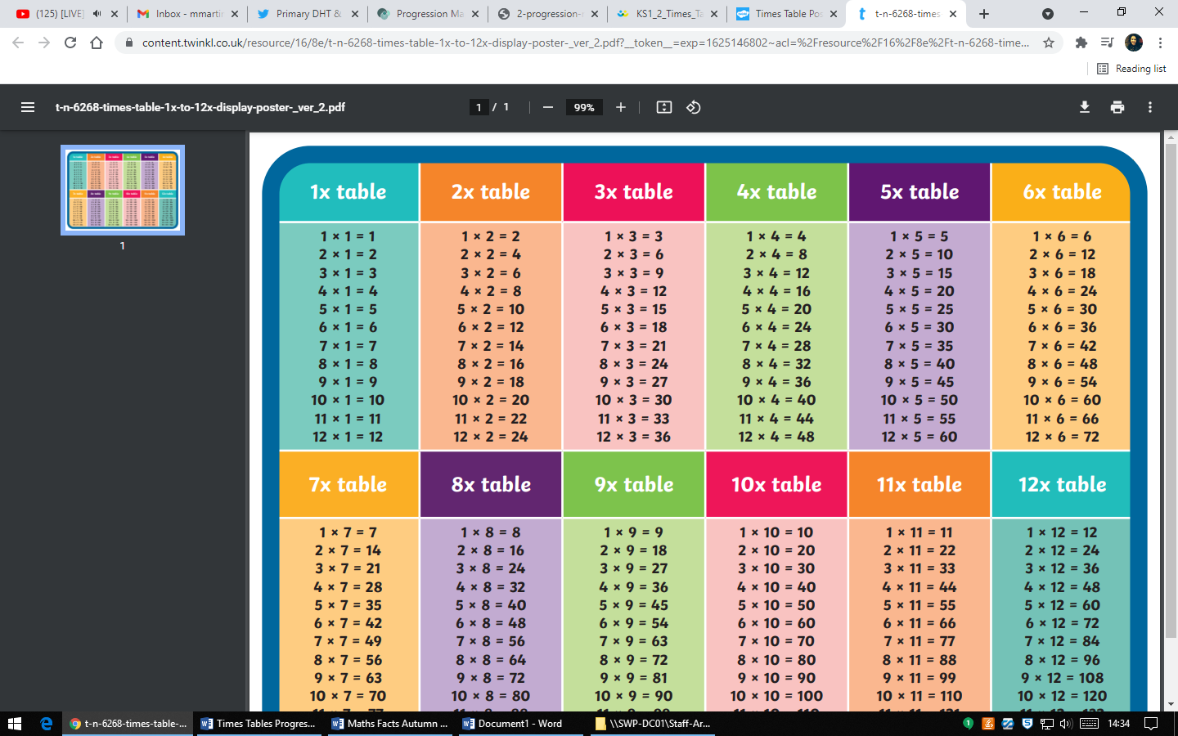 |  | 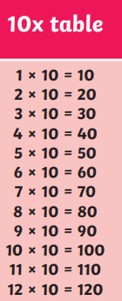
Score: | Score: | Score: | Score:
Week 5  Test: Friday 16th Oct | Week 6  Half Term Assessment: Friday 23rd Oct
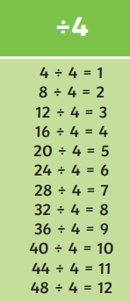 | Children are tested on a range of division and multiplication facts for:  - 2 x table  - 4 x table  - 5 x table  - 10 x table
Score: | Score: | Half Term Assessment Score =

