Springwell Primary School
Science Focus: Animals including Humans |  | Year 2 Autumn Term 1
What should I already know? |  | What will I know by the end of the unit?
- There are a variety of common animals, including fish, amphibians, reptiles, birds and mammals all of which I can name.  - Animals are either carnivores, herbivores or omnivores.  - That I can identify, name, draw and label parts of the body associated with the five senses. |  | - Animals, including humans have offspring which grow into adults.  - The basic needs for animals including humans for survival – water, food and air.  - The importance for exercise, the need to eat right amounts of different types of food, including hygiene.
Key Vocabulary |  | Possible experiences
Offspring  An animal’s young. | Reproduce  An adult that produces offspring. | 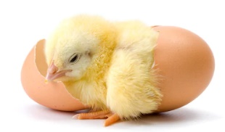  Chick eggs in class to observe growth over time.  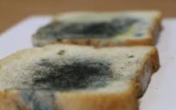  Investigating what happens to bread when it is touched by clean and dirty hands through a controlled experiment.    Investigating the effects that exercise has on the body.  Measuring our own growth over time.    Making a healthy sandwich and fruit smoothies.
Grow  To increase in size and change physically. | Hygiene  A practice to maintain good hygiene.
Adults  A person who is fully grown and developed. | Nutrition  Found in food that is necessary for good health and growth.
Survival  Continuing to live. | Baby  A very young child who is dependent on an adult.
Water  Fluid for living things. | Toddler  A young child who is beginning to walk.
Food  A substance that animals and humans eat. | Child  A young child below the age of 13.
Exercise  An activity that improves health. | Teenager  A person aged between 13 and 19 years.


