Springwell Primary School
Science Focus: Uses of Everyday Materials |  | Year 2 Spring Term
What should I already know? |  | What will I know by the end of the unit?
- A variety of everyday materials, including wood, plastic, glass, metal, water and rock.  - Different materials have certain properties. E.g. Glass is transparent, metal is mostly shiny and can be strong.  - Metals can be grouped on the basis of their properties. |  | - How to compare the uses of a variety of everyday materials, including wood, metal, plastic, glass, brick, rock, paper and cardboard for particular uses.  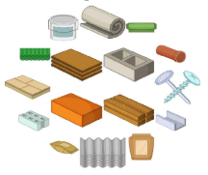  - That the shapes of solid objects made from some materials can be changed by squashing, bending, twisting and stretching.
Properties of materials
Material | Image | Properties | What could it be used for?
Metal | 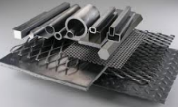 | Metals are often strong, shiny, hard and long lasting. Metals can be hammered into different shapes. | Metals can be made into things like pots and pans.  Metals can be stretched into strips of wire and rods.
Glass | 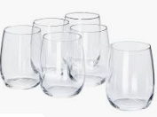 | Glass can be strong, but thin glass can shatter.  Glass is transparent and waterproof. It can be made into different shapes. | Glass can be made for windows, vases, bowls and furniture such as tables and mirrors.
Wood | 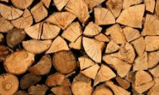 | Wood is hard and strong. Wood is a natural material and can be long lasting. Wood is flammable. | Wood can be used for furniture and for the structure of a house.
Plastic | 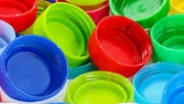 | Plastic can be hard and tough or soft and flexible. Plastic can be moulded into any shape. Plastic can be any colour and can be transparent. | Plastics can be used for toys, bottles, furniture, cutlery and many other items.
Brick | 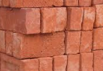 | Bricks are hard and strong. They can be difficult to break. Bricks are good for holding in heat. | Bricks can be used for building houses and walls and for paving such as driveways.
Paper | 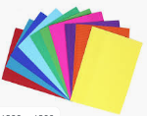 | Paper can be cut into any shaped. Paper is easily torn and when wet it will be soggy. Paper can be dyed any colour. | Paper is used for writing and can be printed on for books.
Properties of materials vocabulary
Hard Squashy Smooth Bumpy Bouncy Dull Flexible Flammable Translucent Waterproof Firm Soft
Possible experiences
Experimenting the uses of different materials and how and if their properties can be changed.
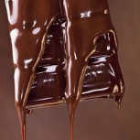
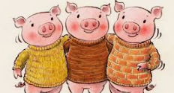
Materials workshop
Exploring which materials are
suitable for a free standing house
for the 3 little pigs.

