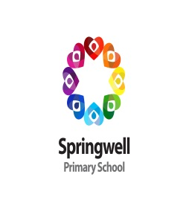
Autumn 1 Spellings

Stage 1  ‘ow’ sound  Test date: 10/09/24 | Stage 2  ‘u’ sound  Test date: 17/09/24 | Stage 3  ‘i’ sound  Test date: 24/09/24 | Stage 4  ‘sure’ ending  Test date: 01/10/24
mouth  around  sprout  sound  spout  ouch  hound  trout  found  proud | touch  double  country  trouble  young  cousin  enough  couple  encourage  flourish | gym  myth  Egypt  pyramid  mystery  symbol  synonym  lyrics  system  gymnastics | measure  treasure  pleasure  enclosure  pressure  composure  leisure  exposure  closure  disclosure
Score: | Score: | Score: | Score:
Stage 5  ‘ture’ ending  Test date: 08/10/24 | Stage 6  challenge words  Test date: 15/10/24 | Stage 7  ‘re’ prefix  Test date: 22/10/24
creature  furniture  picture  nature  adventure  capture  future  sculpture  fracture  mixture | actual  answer  bicycle  circle  earth  enough  fruit  island  often  popular | redo  refresh  return  reappear  redecorate  revenge  review  replay  reaction  rebound
Score: | Score: | Score:
Spellings I would like to work on next half term:

